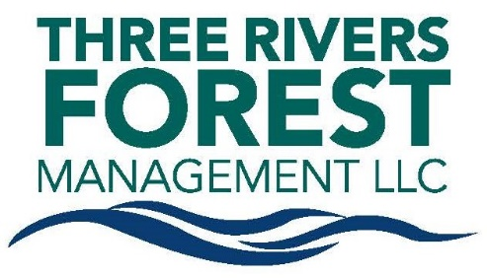

Based in Coudersport, Pennsylvania, Three Rivers Forest Management is responsible for the management of nearly 159,000 acres of forestland in north central Pennsylvania and southern New York. It is a portfolio company of The Lyme Timber Company.

The Lyme Timber Company, founded in 1976 and based in Hanover, New Hampshire, is a timberland investment manager that specializes in the acquisition and sustainable management of land with unique conservation values. It owns and manages approximately 1.6 million of forestland throughout the United States.
Forestry Intern - Coudersport, PA
The forestry intern will have the opportunity to mentor alongside Three Rivers Forest Management staff throughout the geographically diverse, industrial, 159,000-acre land base and will gain real world experience while getting exposure to the day-to-day operations of our timberlands staff.
Job Duties:

- Harvest operations layout
- Timber marking and tally
- Inventory
- Boundary line maintenance
- SMZ delineation
- GIS data entry and collection
- Harvest unit boundary determinations
- Culvert and BMP inspections
- Road layout and design
- Regeneration surveys
- Active harvest field inspections
- Forest health assessments

Education:
Enrolled in a forestry program or a closely related field of studies at an accredited university or college OR be successfully graduated from such a program.
Other Requirements:
• Must have completed your freshman year by the start of the internship
• Must possess a valid driver’s license and an acceptable driving record
• Successfully pass a background check
• Ability to read a map and utilize a compass for navigation
• Willing to work in the field during inclement conditions and with minimal supervision
Pay Scale:
$14-$19/hour depending on: level of schooling, prior internships, summer jobs, volunteer work
Contact Info:
David Andrus at david@threeriversforest.com / 814-320-3694
Joe Glover at jglover@threeriversforest.com / 814-229-0496
Company website at https://www.threeriversforest.com and https://lymetimber.com/

