Pennsylvania Chapter
The American Chestnut Foundation
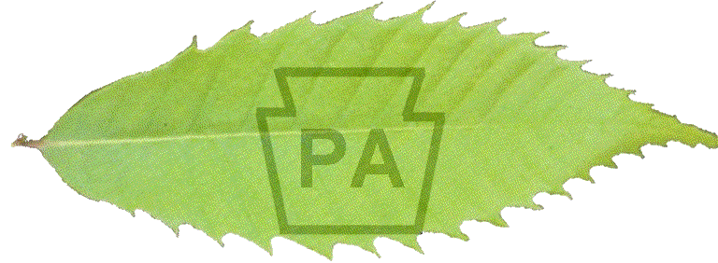
691 Pumping Station Road
Hanover, PA 17331-8608
(717) 632-8669
operations@patacf.org
www.patacf.org

President

Bob Summersgill

Vice President
Tim Phelps

Past President
Phil Gruszka

Chapter Scientist

Dr. Bob Leffel

Operations/Treasurer
Dave Armstrong
Board Members

Ann Leffel
Tom Pugel
Blair Carbaugh
Tracey Coulter
Lee Saufley
Greg Yochum
Alex Day (PA-DCNR)

July 29, 2026

PA-TACF Executive Board Meeting Minutes of March 21, 2003 at Hershey, PA

The Board met at 3:00 p.m. at the Milton Hershey Horticulture Center conference room. The following board members were present: President Bob Summersgill, Vice President Tim Phelps, Past President Phil Gruszka, Board Members: Ann Leffel, Lee Saufley, Blair Carbaugh, Tom Pugel, and Alex Day.
Non-voting members present were Grants Chairman Larry Patchel, Tree Breeding Coordinator Sara Fern Fitzsimmons, Lancaster County Coordinator Don Franks, Chapter Scientist Bob Leffel, Operations Coordinator/Treasurer Dave Armstrong.

1. Reports:
PA-DCNR Lease Agreement for Penn Nursery Orchards. Bob Summersgill reported that TACF approved the concept of our DCNR lease agreement at the TACF meeting in Pittsburg, Pa. Alex Day is making final adjustments to the agreement with the DCNR General Council’s Office, Virginia Davison.
The general consensus of the board is that we will place only PA material at Penn Nurseries and not TACF Regional material to avoid any germplasm agreement complications. Current plans are to place the 5th generation (BC3F2) TACF material at PSU over the next several years and allow the material to revert to TACF control for subsequent breeding activity.

NJ Nature Conservancy. Bob Summersgill reported that there is adequate space and maintenance capability at the Conservancy to place our ‘Graves’ BC3F2 orchard as well as capacity for a PA Program (CMS) orchard. He is continuing to work with the Conservancy regarding locations, fencing, etc.

TACF Bylaws. Bob reported that the TACF Board reviewed the newly proposed TACF bylaws and approved he draft and are publishing the draft for future review and approval.

Bulk Mailing in PA by TACF. Bob mentioned that TACF Communications Director, Ana Ronderos, plans to cover southeastern PA with bulk solicitation letters to boost membership.

Breeding Program. Ann Leffel reviewed the PA-TACF Science Committee Report. Copies were distributed at the meeting. The board generally agreed that the PA Backcross program would proceed using CMS as the primary tool within the county breeding programs.

County Coordinator Program. Dave Armstrong reported that to date we have contacted 67 current coordinators and about 50 have agreed to become members of their county coordinator team. Dave plans to continue developing coordinator teams on a regional basis starting with the Counties around PSU, Region 6.
We will emphasize the PA Breeding program (CMS) to our coordinators at tomorrow’s meeting.

Nominations Committee. Bob Summersgill appointed a nominating committee to nominate candidates to run this autumn for three board positions. The three incumbents whose terms expire are Ann Leffel, Tracey Coulter and Tom Pugel. The nominating committee members are Phil Gruszka, Lee Saufley and Tim Phelps.
The Board agreed that the position of Past President and Vice President will be designated as the standing nominations committee and it would be augmented with other board members as needed.

Industry Representative on the Executive Board. The Board generally agreed to nominate Blain Fuller, Kane Hardwoods, on the PA-TACF Board as our industry representative after he attends a board meeting and everyone gets a chance to meet him.

Chapter Finances. Treasurer Dave Armstrong reviewed the status of our net worth, income & expenses for the end of 2002 and year to date 2003. Copies were distributed at the meeting.

David J Armstrong
PA-TACF Operations Coordinator/Treasurer

